Table Structure

department Table
CREATE TABLE t_department
(
c_dept_deptid INTEGER GENERATED BY DEFAULT AS IDENTITY PRIMARY KEY,
c_dept_deptname VARCHAR(50) NOT NULL,
c_dept_city VARCHAR(50) NOT NULL
);
INSERT INTO t_department
(
c_dept_deptid,
c_dept_deptname,
c_dept_city
)
VALUES
(1, 'HR', 'Mumbai'),
(2, 'Finance', 'Delhi'),
(3, 'IT', 'Chennai'),
(4, 'Marketing','Kolkata');
employee Table
CREATE TABLE t_employee
(
c_emp_empid INTEGER GENERATED BY DEFAULT AS IDENTITY PRIMARY KEY,
c_emp_empname VARCHAR(50)NOT NULL,
c_emp_desig VARCHAR(50) NOT NULL,
c_emp_salary NUMERIC(10,2) CHECK (c_emp_salary > 0),
c_emp_hiredate DATE DEFAULT CURRENT_DATE,
c_emp_mgrno INTEGER,
c_emp_deptid INTEGER,
c_emp_city VARCHAR(50) NOT NULL,
c_emp_email VARCHAR(100) NOT NULL UNIQUE,
CONSTRAINT fk_emp_department FOREIGN KEY (c_emp_deptid) REFERENCES t_department(c_dept_deptid),
CONSTRAINT fk_emp_manager FOREIGN KEY (c_emp_mgrno) REFERENCES t_employee(c_emp_empid)
);

INSERT INTO t_employee
(
c_emp_empid,
c_emp_empname,
c_emp_desig,
c_emp_salary,
c_emp_hiredate,
c_emp_mgrno,
c_emp_deptid,
c_emp_city,
c_emp_email
)
VALUES
(1, 'Rajesh Kumar', 'Manager', 90000.00, '2023-01-01', NULL, 1, 'Mumbai', 'Rajesh.kumar@example.com'),
(2, 'Sita Sharma', 'Analyst', 70000.00, '2023-05-10', 1, 2, 'Delhi', 'Sita.sharma@example.com'),
(3, 'Anil Mehra', 'Developer', 60000.00, '2023-03-15', 1, 3, 'Chennai', 'Anil.mehra@example.com'),
(4, 'Priya Nair', 'Executive', 50000.00, '2023-07-25', 2, 4, 'Kolkata', 'Priya.nair@example.com'),
(5, 'Mohan Gupta', 'Developer', 65000.00, '2023-06-05', 1, 3, 'Chennai', 'Mohan.gupta@example.com'),
(6, 'Kavita Singh', 'Analyst', 72000.00, '2023-04-20', 2, 2, 'Delhi', 'Kavita.singh@example.com'),
(7, 'Vikram Desai', 'Manager', 95000.00, '2023-02-01', NULL, 1, 'Mumbai', 'Vikram.desai@example.com'),
(8, 'Ananya Rao', 'Executive', 52000.00, '2023-08-10', 4, NULL, 'Bangalore', 'Ananya.rao@example.com'),
(9, 'Suraj Patil', 'Developer', 60000.00, '2023-07-01', 3, 3, 'Chennai', 'Suraj.patil@example.com'),
(10, 'Meera Iyer', 'Executive', 51000.00, '2023-07-15', 2, 4, 'Kolkata', 'Meera.iyer@example.com'),
(11, 'Arun Menon', 'Developer', 68000.00, '2023-03-01', 1, 3, 'Chennai', 'Arun.menon@example.com'),
(12, 'Sunil Yadav', 'Analyst', 75000.00, '2023-06-10', 2, 2, 'Delhi', 'Sunil.yadav@example.com'),
(13, 'Deepa Joshi', 'Executive', 55000.00, '2023-09-01', 4, 4, 'Kolkata', 'Deepa.joshi@example.com'),
(14, 'Naveen Sharma','Manager', 92000.00, '2023-01-10', NULL, 1, 'Mumbai', 'Naveen.sharma@example.com'),
(15, 'Rakesh Nair', 'Developer', 62000.00, '2023-05-01', 3, 3, 'Chennai', 'Rakesh.nair@example.com');

CTE (Common Table Expression)
Q1 | Write a query using a CTE to find the total number of employees in each department in ascending order.
Query | WITH dept_employee_count AS  (  SELECT  c_emp_deptid,  COUNT(*) AS total_employee  FROM t_employee  WHERE c_emp_deptid IS NOT NULL  GROUP BY c_emp_deptid  )  SELECT  d.c_dept_deptid,  d.c_dept_deptname,  dec.total_employee  FROM t_department d  JOIN dept_employee_count dec  ON d.c_dept_deptid = dec.c_emp_deptid  ORDER BY dec.total_employee ASC;
Output | 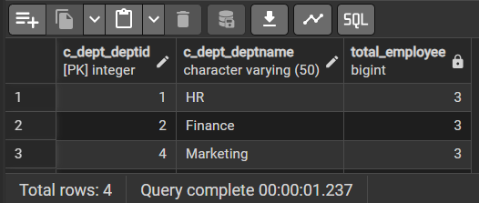

Q2 | Use a CTE to retrieve employees and salary along with the average salary of its city employees.
Query | WITH city_average_salary AS  (  SELECT  c_emp_city,  AVG(c_emp_salary) AS avg_city_salary  FROM t_employee  GROUP BY c_emp_city  )  SELECT  e.c_emp_empname,  e.c_emp_salary,  e.c_emp_city,  cas.avg_city_salary  FROM t_employee e  JOIN city_average_salary cas  ON e.c_emp_city = cas.c_emp_city;
Output | 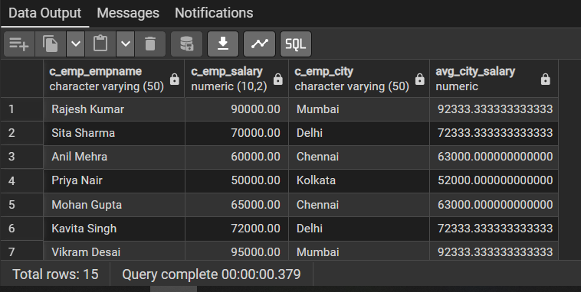

Q3 | Create a CTE that lists employees along with the number of employees in their respective cities descending order.
Query | WITH city_employee_count AS  (  SELECT  c_emp_city,  COUNT(*) AS total_city_employee  FROM t_employee  GROUP BY c_emp_city  )  SELECT  e.c_emp_empname,  e.c_emp_city,  cec.total_city_employee  FROM t_employee e  JOIN city_employee_count cec  ON e.c_emp_city = cec.c_emp_city  ORDER BY cec.total_city_employee DESC;
Output | 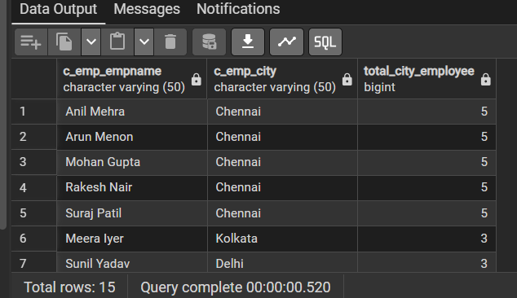

Q4 | Use a CTE to calculate the total and average salary for each designation where total salary>200000 and average salary> 60000.
Query | WITH designation_salary AS  (  SELECT  c_emp_desig,  SUM(c_emp_salary) AS total_salary,  AVG(c_emp_salary) AS average_salary  FROM t_employee  GROUP BY c_emp_desig  )  SELECT  c_emp_desig,  total_salary,  average_salary  FROM designation_salary  WHERE total_salary > 200000  AND average_salary > 60000;
Output | 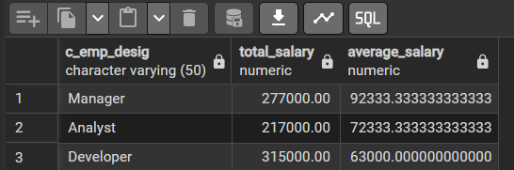

ROLLUP Query

Q1 | Write a query using ROLLUP to get the total salary by department and city, including subtotals.
Query | WITH designation_salary AS  (  SELECT  c_emp_desig,  SUM(c_emp_salary) AS total_salary,  AVG(c_emp_salary) AS average_salary  FROM t_employee  GROUP BY c_emp_desig  )  SELECT  c_emp_desig,  total_salary,  average_salary  FROM designation_salary  WHERE total_salary > 200000  AND average_salary > 60000;  SELECT  d.c_dept_deptname,  e.c_emp_city,  SUM(e.c_emp_salary) AS total_salary  FROM t_employee e  LEFT JOIN t_department d  ON e.c_emp_deptid = d.c_dept_deptid  GROUP BY ROLLUP  (  d.c_dept_deptname,  e.c_emp_city  );
Output | 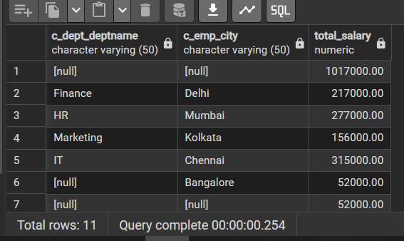

Q2 | Use ROLLUP to find the total number of employees grouped by department and designation, including subtotals for each department.
Query | SELECT  d.c_dept_deptname,  e.c_emp_desig,  COUNT(*) AS total_employee  FROM t_employee e  LEFT JOIN t_department d  ON e.c_emp_deptid = d.c_dept_deptid  GROUP BY ROLLUP  (  d.c_dept_deptname,  e.c_emp_desig  );
Output | 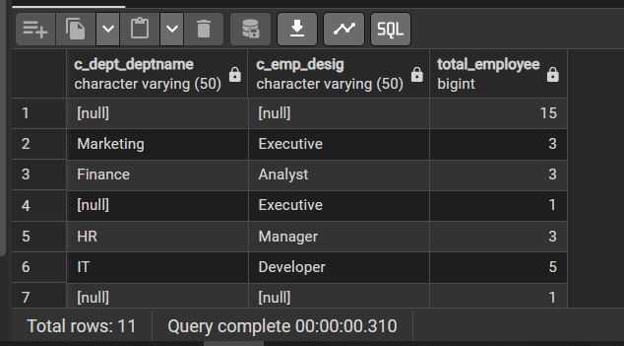

Q3 | Write a query using ROLLUP to get the total and average salary for each city, including grand totals.
Query | SELECT  c_emp_city,  SUM(c_emp_salary) AS total_salary,  AVG(c_emp_salary) AS average_salary  FROM t_employee  GROUP BY ROLLUP(c_emp_city);
Output | 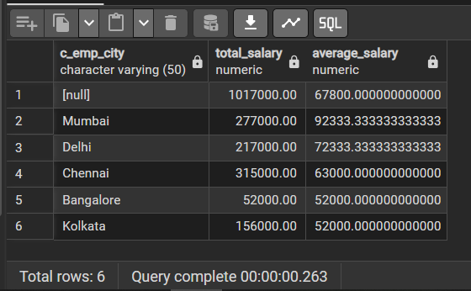

CUBE Query

Q1 | Write a query using CUBE to find the total salary grouped by department and city, including all possible combinations of totals.
Query | SELECT  d.c_dept_deptname,  e.c_emp_city,  SUM(e.c_emp_salary) AS total_salary  FROM t_employee e  LEFT JOIN t_department d  ON e.c_emp_deptid = d.c_dept_deptid  GROUP BY CUBE  (  d.c_dept_deptname,  e.c_emp_city  );
Output | 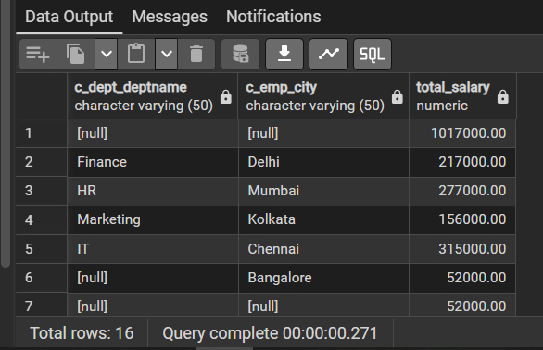

Q2 | Use CUBE to retrieve the number of employees for each designation and city, including all combinations of subtotals.
Query | SELECT  c_emp_desig,  c_emp_city,  COUNT(*) AS total_employee  FROM t_employee  GROUP BY CUBE  (  c_emp_desig,  c_emp_city  );
Output | 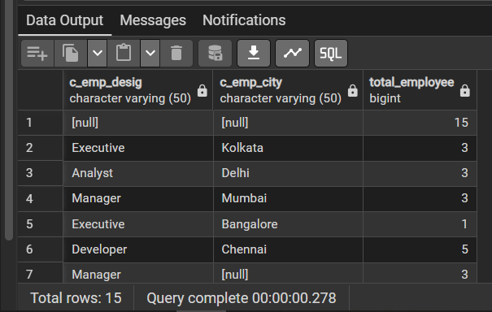

Q3 | Write a query using CUBE to get the total salary paid by department, city, and designation, including all combinations of subtotals.
Query | SELECT  d.c_dept_deptname,  e.c_emp_city,  e.c_emp_desig,  SUM(e.c_emp_salary) AS total_salary  FROM t_employee e  LEFT JOIN t_department d  ON e.c_emp_deptid = d.c_dept_deptid  GROUP BY CUBE  (  d.c_dept_deptname,  e.c_emp_city,  e.c_emp_desig  );
Output | 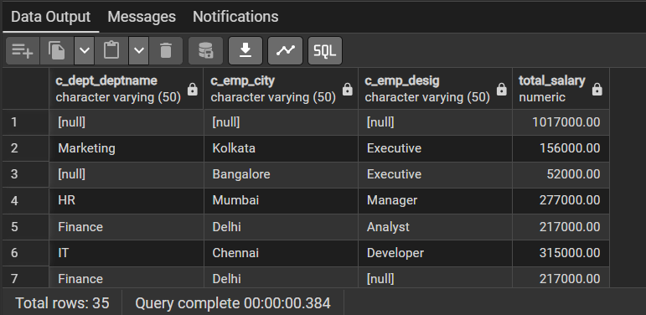

PARTITION BY & ROW_NUMBER()

Q1 | Use ROW_NUMBER() with PARTITION BY to list employees in each department, ordered by salary in descending order.
Query | SELECT  c_emp_empid,  c_emp_empname,  c_emp_deptid,  c_emp_salary,  ROW_NUMBER() OVER  (  PARTITION BY c_emp_deptid  ORDER BY c_emp_salary DESC  ) AS row_number  FROM t_employee;
Output | 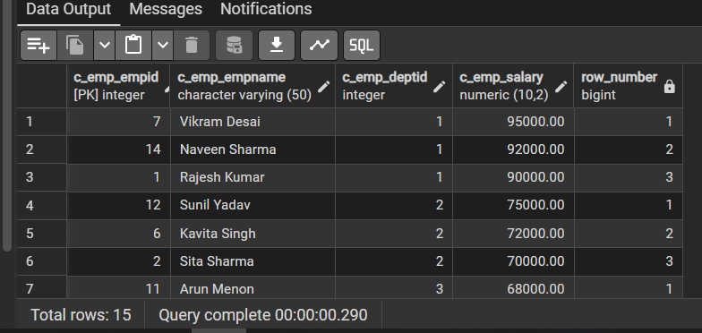

Q2 | Retrieve the top 2 highest-paid employees in each city using PARTITION BY and ROW_NUMBER().
Query | WITH ranked_employee AS  (  SELECT  c_emp_empid,  c_emp_empname,  c_emp_city,  c_emp_salary,  ROW_NUMBER() OVER  (  PARTITION BY c_emp_city  ORDER BY c_emp_salary DESC  ) AS rn  FROM t_employee  )  SELECT  c_emp_empid,  c_emp_empname,  c_emp_city,  c_emp_salary  FROM ranked_employee  WHERE rn <= 2;
Output | 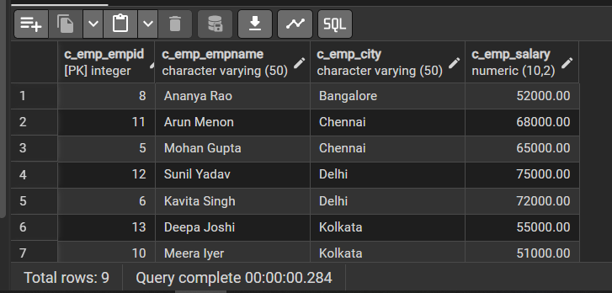

Q3 | Use ROW_NUMBER() to get the second highest-paid employee from each department.
Query | WITH ranked_employee AS  (  SELECT  c_emp_empid,  c_emp_empname,  c_emp_deptid,  c_emp_salary,  ROW_NUMBER() OVER  (  PARTITION BY c_emp_deptid  ORDER BY c_emp_salary DESC  ) AS rn  FROM t_employee  WHERE c_emp_deptid IS NOT NULL  )  SELECT  c_emp_empid,  c_emp_empname,  c_emp_deptid,  c_emp_salary  FROM ranked_employee  WHERE rn = 2;
Output | 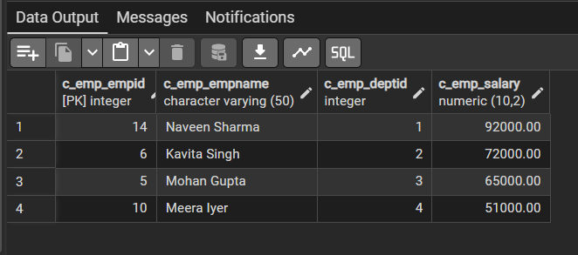

Q4 | List the first 3 employees hired in each department using PARTITION BY and ROW_NUMBER().
Query | WITH hired_employee AS  (  SELECT  c_emp_empid,  c_emp_empname,  c_emp_deptid,  c_emp_hiredate,  ROW_NUMBER() OVER  (  PARTITION BY c_emp_deptid  ORDER BY c_emp_hiredate ASC  ) AS rn  FROM t_employee  WHERE c_emp_deptid IS NOT NULL  )  SELECT  c_emp_empid,  c_emp_empname,  c_emp_deptid,  c_emp_hiredate  FROM hired_employee  WHERE rn <= 3;
Output | 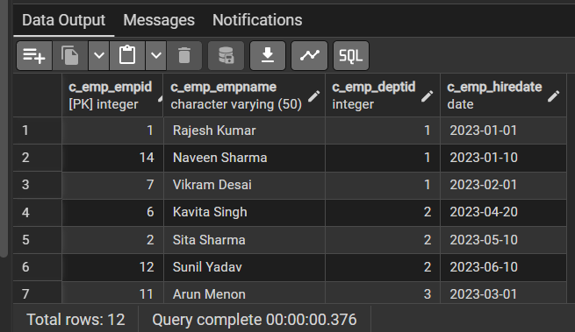

PARTITION BY & RANK()

Q1 | Use RANK() to find employees with the second highest salary in each department.
Query | WITH ranked_employee AS  (  SELECT  c_emp_empid,  c_emp_empname,  c_emp_deptid,  c_emp_salary,  RANK() OVER  (  PARTITION BY c_emp_deptid  ORDER BY c_emp_salary DESC  ) AS salary_rank  FROM t_employee  WHERE c_emp_deptid IS NOT NULL  )  SELECT  c_emp_empid,  c_emp_empname,  c_emp_deptid,  c_emp_salary  FROM ranked_employee  WHERE salary_rank = 2;
Output | 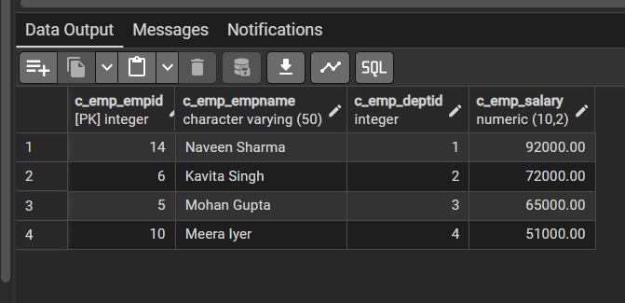

Q2 | Use RANK() to list employees who are ranked 1st or 2nd by salary within each department.
Query | WITH ranked_employee AS  (  SELECT  c_emp_empid,  c_emp_empname,  c_emp_deptid,  c_emp_salary,  RANK() OVER  (  PARTITION BY c_emp_deptid  ORDER BY c_emp_salary DESC  ) AS salary_rank  FROM t_employee  WHERE c_emp_deptid IS NOT NULL  )  SELECT  c_emp_empid,  c_emp_empname,  c_emp_deptid,  c_emp_salary,  salary_rank  FROM ranked_employee  WHERE salary_rank <= 2;
Output | 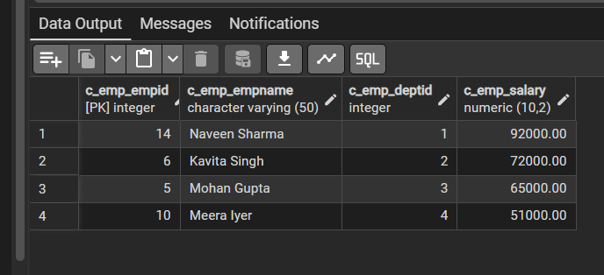

Q3 | Use RANK() to list the highest-paid employees in each department who have a salary greater than 80,000.
Query | WITH ranked_employee AS  (  SELECT  c_emp_empid,  c_emp_empname,  c_emp_deptid,  c_emp_salary,  RANK() OVER  (  PARTITION BY c_emp_deptid  ORDER BY c_emp_salary DESC  ) AS salary_rank  FROM t_employee  WHERE c_emp_salary > 80000  AND c_emp_deptid IS NOT NULL  )  SELECT  c_emp_empid,  c_emp_empname,  c_emp_deptid,  c_emp_salary  FROM ranked_employee  WHERE salary_rank = 1;
Output | 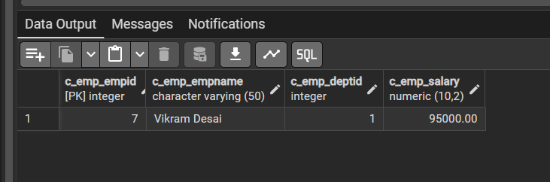

Q4 | Retrieve the employees who are ranked in the top 5 based on salary in their respective cities.
Query | WITH ranked_employee AS  (  SELECT  c_emp_empid,  c_emp_empname,  c_emp_city,  c_emp_salary,  RANK() OVER  (  PARTITION BY c_emp_city  ORDER BY c_emp_salary DESC  ) AS salary_rank  FROM t_employee  )  SELECT  c_emp_empid,  c_emp_empname,  c_emp_city,  c_emp_salary,  salary_rank  FROM ranked_employee  WHERE salary_rank <= 5;
Output | 